**The Seismic Network**

**Of**

**Miami Quarry Blasts**

**Miami Network History**

The network installation effort started in 2019. 3 instruments were installed on July 2nd and the 4th one was installed 4 days later in the vicinity of Miami lakes quarry blasts.

The name of the instruments was chosen to be people’s names who installed the instruments in their houses. These instruments included, Irene that had a 3 component instrument called station R976A, Oscar that has also a 3 component seismogram called station REFFB which on December 10th, 2019 it was removed from his house and added to MAS design on December 16th, and the 3rd instrument was installed in Oscar’s next-door house, Miguel, which is an infrasound instrument called station RCC6E. This network was aimed to record the blasts of one quarry blast which later other quarries were recognized and the network expanded. Figure 1 shows the network for quarry blasts in Miami with seismic and infrasound instruments indicator.

The 4th instrument which was installed 4 days later and started functioning the next day installed in Nancy’s house. It’s a 3 component instrument as well that is called station R4FF5.

Later on August 29th, the instrument on the R976A station stopped functioning and moved to a new location down to the quarry and started to record the blasts again on the 16 of October 2019. 2 other instruments were added to the network on the same day, called R6324 and R17FC stations which R6324 is a 3 component instrument that moved from its initial location in St. Pete to miami and R17FC is an infrasound instrument located to the south of two main quarries in the study area.

The initial network aimed to record the blasts on 1 quarry which was known at the time the study started. Later, some other quarries were recognized which the two added instruments played an important role in the network due to broadening the study area because R6324 was next to the second quarry blast and R17FC station was far from both quarries to build a well-covered network array but unfortunately, after December 16th, the station recorded smaller seismic waves and showed a partial malfunction on 3 component but the infrasound works well, and the R4FF5 station stopped working.

The last instrument which was added to the network by an unknown person is on RC57A station that started recording the blasts on November 5th, 2020. This station is located to the North of the quarry blasts.

All stations are Raspberry Shake[1] (RS). Raspberry Shake is an all-in-one personal Seismograph that integrates a 3 orthogonal velocity, the digitalizes, the hyper dampers, and the computer into a single box. The recorded events are possible to be downloaded in a file on computers from Raspberry Shake. A network timeline and the instrument’s names are shown on tables 1 and 2. Relocated instruments are differentiated by an “ * ” in both tables.

**Table 1. Deployed Network Timeline from July 2nd, 2019 to November 5th, 2020 in quarry blasts of Miami.**

|  |  |  |
| --- | --- | --- |
| **Miami Network Timeline** | | |
| July 2, 2019 | 4 stations deployed | RCC6E, R976A, R4FF5, REFFB |
| Aug 29, 2019 | 2 stations added | R6324*, R17FC |
| Aug 29, 2019 | station removed | R976A |
| Oct 16, 2019 | new location | R976A* |
| Dec 10, 2019 | station removed | REFFB |
| Dec 16, 2019 | new location | REFFB* |
| Dec 16, 2019 | Malfunction(smaller seismic) | R17FC |
| Nov 23, 2020 | station stopped working | R4FF5 |
| Nov 5, 2020 | station added | RC57A |

**Table 2. Instrument names, types, locations and dates of operation in 2019.**

|  |  |  |  |  |
| --- | --- | --- | --- | --- |
| **Name/Date** | **Address** | **Location/lat-long** | **RS name** | **Instr. type** |
| Irene | 17675 NW 91 Ct, Hialeah, FL 33018 | 25.9336 N | R976A | RS3D |
| 80.3494 W |
| Oscar | 18784 NW 79 Pl, Hialeah, FL 33015 | 25.9447 N | RCC6E | RS+Boom |
| 80.3310 W |
| Nancy | 15979 SW 54 Ct, Miramar, FL 33027 | 25.9576 N | R4FF5 | RS3D |
| 80.3615 W |
| Steve | 6200 18th St NE. St. Pete, FL 33702 | 27.8301 N | R6324 | RS3D |
| 82.6121 W |
| Muslim | 17551 NW 137 Ave. Hialeah Gardens, FL | 25.9325 N | R6324* | RS3D |
| 80.4217 W |
| Orlando | 10199 NW 129 Terrace, Hialeah Gardens, FL 33018 | 25.8908 N | R17FC | RS+Boom |
| 80.3636 W |
| Aragon | 8700 W 35th Ct, Hialeah, FL 33018 | 25.9016 N | R976A * | RS3D |
| 80.3544 W |
| MAS Design | 17670 NW 78th Ave. Miami, FL 33015 | 25.9339 N | REFFB* | RS3D |
| 80.3279 W |
| Unknown |  | 26 N | RC57A | RS3D |
| 80.35 W |

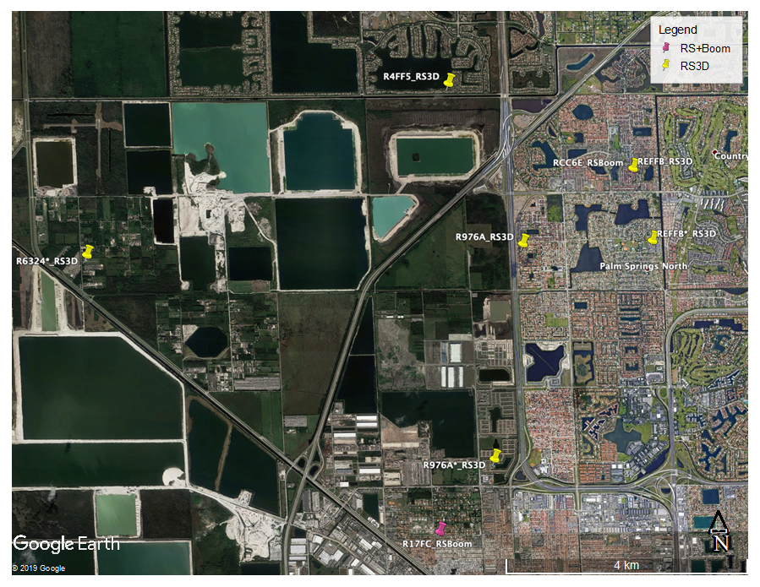Figure 1. Map of seismic and infrasound stations in Miami Lakes. Moved stations are shown with “*”.

1. More information on [sales@raspberryshake.org](mailto:sales@raspberryshake.org)